CTS WEEK 6:
9. ReactJS-HOL:
Solution:
src/
│
├── components/
│ ├── ListOfPlayers.js
│ └── IndianPlayers.js
├── App.js
├── index.js

Component 1: ListOfPlayers.js
import React from 'react';
function ListOfPlayers() {
const players = [
{ name: "Virat Kohli", score: 85 },
{ name: "Rohit Sharma", score: 92 },
{ name: "Shubman Gill", score: 67 },
{ name: "Suryakumar Yadav", score: 55 },
{ name: "Hardik Pandya", score: 45 },
{ name: "Ravindra Jadeja", score: 70 },
{ name: "R Ashwin", score: 60 },
{ name: "KL Rahul", score: 82 },
{ name: "Shreyas Iyer", score: 90 },
{ name: "Jasprit Bumrah", score: 35 },
{ name: "Mohammed Siraj", score: 25 }, ];
const below70 = players.filter(player => player.score < 70);
return (
<div>
<h2>All Players</h2>
<ul>
{players.map((p, index) => (
<li key={index}>{p.name} - {p.score}</li>
))}
</ul>
<h3>Players with score below 70</h3>
<ul>
{below70.map((p, index) => (
<li key={index}>{p.name} - {p.score}</li> ))}
</ul>
</div>
);}
export default ListOfPlayers;

Component 2: IndianPlayers.js
import React from 'react';
function IndianPlayers() {
const team = ["Virat", "Rohit", "Gill", "Surya", "Hardik", "Jadeja", "Ashwin", "Rahul"];
const oddTeam = team.filter((_, index) => index % 2 === 0);
const evenTeam = team.filter((_, index) => index % 2 !== 0);
const [t20_1, t20_2, ...t20rest] = ["Bumrah", "Shami", "Chahal", "Kuldeep"];
const [ranji_1, ranji_2, ...ranjirest] = ["Pujara", "Rahane", "Ishant", "Umesh"];
const mergedTeam = [...t20rest, ...ranjirest];
return (
<div>
<h2>Odd Team Players</h2>
<ul>
{oddTeam.map((p, index) => <li key={index}>{p}</li>)}
</ul>
<h2>Even Team Players</h2>
<ul>
{evenTeam.map((p, index) => <li key={index}>{p}</li>)}
</ul>

<h2>Merged Team (T20 + Ranji)</h2>
<ul>
{mergedTeam.map((p, index) => <li key={index}>{p}</li>)}
</ul>
</div>
);
}
export default IndianPlayers;

App.js (Display Based on Flag)
import React from 'react';
import ListOfPlayers from './components/ListOfPlayers';
import IndianPlayers from './components/IndianPlayers';
function App() {
const flag = true; // change to false to switch
return (
<div>
<h1>🏏 Cricket App Dashboard</h1>
{flag ? <ListOfPlayers /> : <IndianPlayers />}
</div>);}
export default App;

OUTPUT: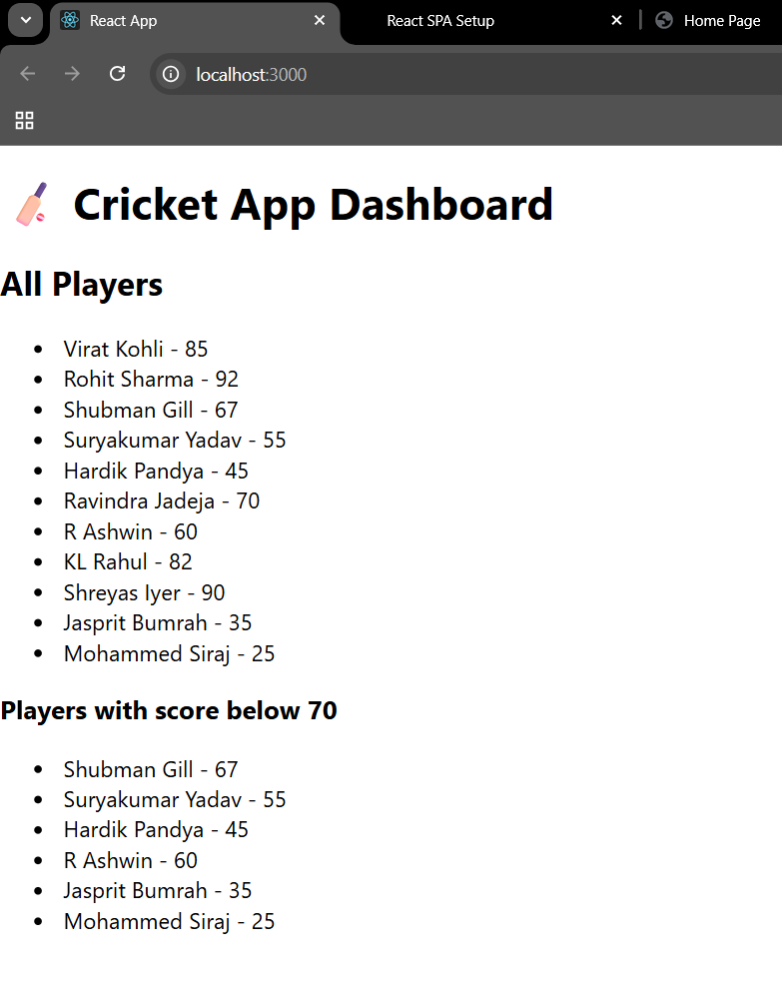

10. ReactJS-HOL:
Solution:
officespacerentalapp/
├── public/
│ └── index.html
├── src/
│ ├── App.js
│ └── office.jpg <-- Place your office image here
├── package.json
└── ...
App.js
import React from 'react';
import officeImage from './office.jpg'; // Make sure this image is in the src folder

function App() {
const officeSpaces = [
{
name: "DBS",
rent: 50000,
address: "Chennai"
},
{
name: "WeWork",
rent: 70000,
address: "Bangalore"
},
{
name: "Regus",
rent: 55000,
address: "Hyderabad"
}
];

return (
<div style={{ padding: "30px", fontFamily: "Arial" }}>
<h1><b>Office Space , at Affordable Range</b></h1>

<img
src={officeImage}
alt="Office Space"
width="300"
style={{ marginTop: "20px", marginBottom: "20px" }}
/>

{officeSpaces.map((office, index) => (
<div key={index} style={{ marginBottom: "20px" }}>
<h2><b>Name: {office.name}</b></h2>
<p style={{
color: office.rent < 60000 ? 'red' : 'green',
fontWeight: 'bold'
}}>
Rent: Rs. {office.rent}
</p>
<p><b>Address:</b> {office.address}</p>
</div>
))}
</div>
);
}

export default App;
Office.jpg

OUTPUT:
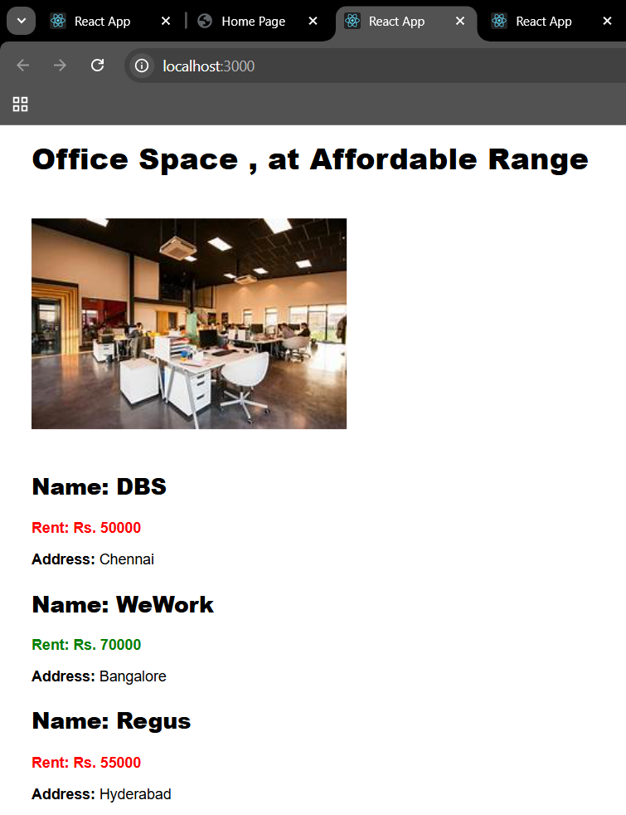
11. ReactJS-HOL:
eventexamplesapp/
├── public/
│ └── index.html
├── src/
│ ├── App.js
│ └── CurrencyConverter.js
├── package.json
└── …
App.js
import React, { Component } from 'react';
import CurrencyConvertor from './CurrencyConvertor';
import './App.css';
class App extends Component {
constructor(props) {
super(props);
this.state = {
count: 1
};
}
increment = () => {
this.setState({ count: this.state.count + 1 });
this.sayHello();
};

decrement = () => {
this.setState({ count: this.state.count - 1 });
};
sayHello = () => {
console.log("Hello! Increment button clicked");
};
sayWelcome = (msg) => {
alert("Welcome! Message: " + msg);
};
handleClick = (e) => {
alert("I was clicked");};
render() {
return (
<div style={{ padding: "20px" }}>
<h3>{this.state.count}</h3>
<button onClick={this.increment}>Increment</button>{' '}
<button onClick={this.decrement}>Decrement</button>{' '}
<button onClick={() => this.sayWelcome("welcome")}>Say welcome</button>{' '}
<button onClick={this.handleClick}>Click on me</button>
<hr />
<CurrencyConvertor />
</div> );}}
export default App;

CurrencyConverter.js
import React, { Component } from "react";

class CurrencyConvertor extends Component {
constructor(props) {
super(props);
this.state = {
amount: "",
currency: "Euro"
};
}
handleAmountChange = (e) => {
this.setState({ amount: e.target.value });
};
handleCurrencyChange = (e) => {
this.setState({ currency: e.target.value });
};
handleSubmit = (e) => {
e.preventDefault();
const { amount, currency } = this.state;
let convertedAmount;

if (currency === "Euro") {
convertedAmount = amount * 80;
} else if (currency === "Dollar") {
convertedAmount = amount * 70;
} else {
convertedAmount = amount;
}
alert(`Converting to ${currency} Amount is ${convertedAmount}`);
};
render() {
return (
<div>
<h1 style={{ color: 'green', fontSize: '32px', fontWeight: 'bold' }}>
Currency Convertor!!!
</h1>

<form onSubmit={this.handleSubmit}>
<div>
<label>Amount:</label>
<input
type="number"
value={this.state.amount}
onChange={this.handleAmountChange}
required
/>
</div>
<div>
<label>Currency:</label>
<select
value={this.state.currency}
onChange={this.handleCurrencyChange}
>
<option value="Euro">Euro</option>
<option value="Dollar">Dollar</option>
</select>
</div>
<button type="submit">Submit</button>
</form>
</div>
);
}
}

export default CurrencyConvertor;

OUTPUT:
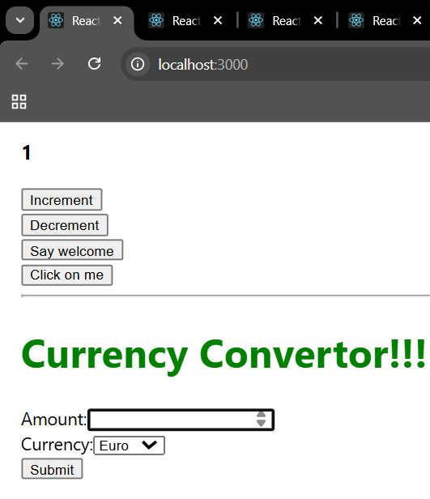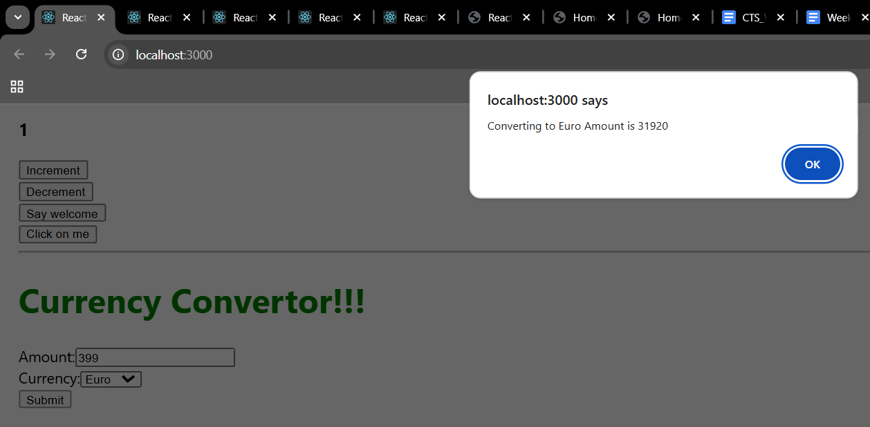

12. ReactJS-HOL:
Solution:
app.js

import React, { Component } from 'react';
class App extends Component {
constructor(props) {
super(props);
this.state = {
isLoggedIn: false
};
}
handleLogin = () => {
this.setState({ isLoggedIn: true });
};

handleLogout = () => {
this.setState({ isLoggedIn: false });
};
render() {
let pageContent;
if (this.state.isLoggedIn) {
pageContent = (
<div>
<h2 style={{ color: 'green' }}>Welcome User!</h2>
<p>You are now logged in and can book tickets.</p>
<button onClick={this.handleLogout}>Logout</button>
<hr />
<h3>Book Your Flight:</h3>
<ul>
<li>Flight AI101 - Delhi to Mumbai - ₹5000</li>
<li>Flight AI202 - Bangalore to Chennai - ₹3000</li>
<li>Flight AI303 - Kolkata to Hyderabad - ₹4500</li>
</ul>
<button>Book Ticket</button>
</div>
);
} else {
pageContent = (
<div>
<h2 style={{ color: 'blue' }}>Welcome Guest!</h2>
<p>Please login to book your tickets.</p>
<button onClick={this.handleLogin}>Login</button>
<hr />
<h3>Available Flights:</h3>
<ul>
<li>Flight AI101 - Delhi to Mumbai</li>
<li>Flight AI202 - Bangalore to Chennai</li>
<li>Flight AI303 - Kolkata to Hyderabad</li>
</ul>
</div>
);
}

return (
<div style={{ padding: '20px', fontFamily: 'Arial' }}>
<h1 style={{ textAlign: 'center', color: '#222' }}>Ticket Booking App</h1>
{pageContent}
</div>
);
}
}

export default App;

Output:
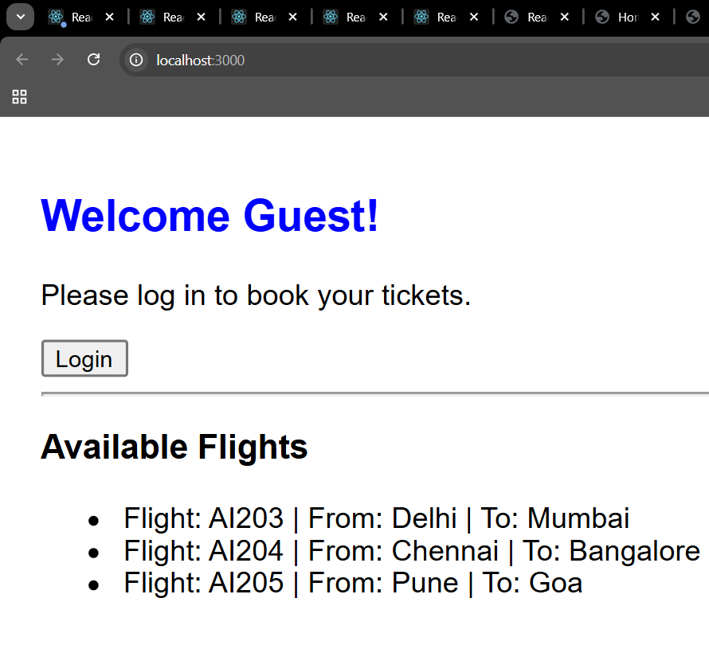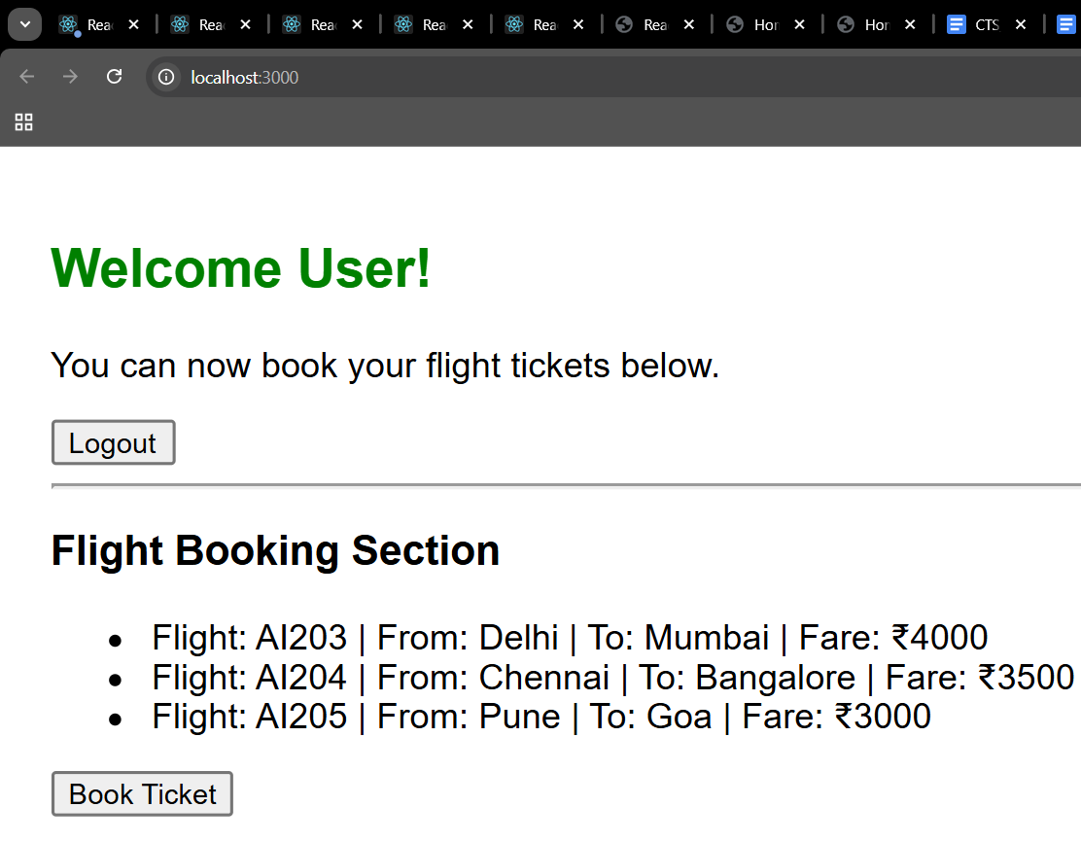
13. ReactJS-HOL:
Solution:
bloggerapp/
├── public/
│ └── index.html
├── src/
│ ├── App.js
│ ├── CourseDetails.js
│ ├── BookDetails.js
│ ├── BlogDetails.js
│ └── index.js
├── package.json
app.js
import React from "react";
import CourseDetails from "./CourseDetails";
import BookDetails from "./BookDetails";
import BlogDetails from "./BlogDetails";

function App() {
return (
<div
style={{
display: "flex",
justifyContent: "space-between",
padding: "50px 80px",
fontFamily: "Arial, sans-serif"
}}
>
<CourseDetails />
<BookDetails />
<BlogDetails />
</div>
);
}
export default App;

CourseDetails.js
import React from "react";
function CourseDetails() {
const courses = [
{ name: "Angular", date: "4/5/2021" },
{ name: "React", date: "6/3/20201" },
];
return (
<div style={{ width: "30%", paddingRight: "20px" }}>
<h2 style={{ fontWeight: "bold", marginBottom: "20px" }}>Course Details</h2>
{courses.map((course, index) => (
<div key={index} style={{ marginBottom: "20px" }}>
<h3 style={{ fontWeight: "bold", margin: "0" }}>{course.name}</h3>
<h4 style={{ margin: "0" }}>{course.date}</h4>
</div>
))}
</div>
);
}
export default CourseDetails;
BookDetails.js
import React from "react";
function BookDetails() {
const books = [
{ id: 1, bname: "Master React", price: 670 },
{ id: 2, bname: "Deep Dive into Angular 11", price: 800 },
{ id: 3, bname: "Mongo Essentials", price: 450 },
];
return (
<div
style={{
width: "30%",
padding: "0 20px",
borderLeft: "4px solid green",
borderRight: "4px solid green" }}
>
<h2 style={{ fontWeight: "bold", marginBottom: "20px" }}>Book Details</h2>
{books.map((book) => (
<div key={book.id} style={{ marginBottom: "20px" }}>
<h3 style={{ fontWeight: "bold", margin: "0" }}>{book.bname}</h3>
<h4 style={{ margin: "0" }}>{book.price}</h4>
</div>
))}
</div>
);
}

export default BookDetails;
BlogDetails.js
import React from "react";
function BlogDetails() {
const blogs = [
{
title: "React Learning",
author: "Stephen Biz",
content: "Welcome to learning React!",
},
{
title: "Installation",
author: "Schewzdenier",
content: "You can install React from npm.",
},
];

return (
<div style={{ width: "30%", paddingLeft: "20px", borderLeft: "4px solid green" }}>
<h2 style={{ fontWeight: "bold", marginBottom: "20px" }}>Blog Details</h2>
{blogs.map((blog, index) => (
<div key={index} style={{ marginBottom: "20px" }}>
<h3 style={{ fontWeight: "bold", margin: "0" }}>{blog.title}</h3>
<h4 style={{ fontWeight: "bold", margin: "0" }}>{blog.author}</h4>
<p style={{ margin: "0" }}>{blog.content}</p>
</div>
))}
</div>
);
}

export default BlogDetails;

OUTPUT:
